Encouraging Socialization with Application Development and Social Gestures Recognition

Alesha Morovits
REU at Temple University
UW-Platteville
Janesville, WI
morovits.a@gmail.com

Jamie Payton
Associate Professor and Chair
Dept. of Computer & Information Sciences
Philadelphia, PA
payton@temple.edu

Abstract—A significant problem in society is social isolation. This lack of connection between an individual and society can be combated with the use of technology. In this paper the combination of gamification and social gesture recognition is applied with application development. It is proposed that the use of auto-detection and gamification will encourage the use to continue using the app to better one’s socialization.

Introduction
The evolution of smart bands allows one to take advantage of the sensors they process. The accelerometer and gyroscope sensors allow researchers to extract data and interpret it depending on their needs. For instance, the data can be used in a model to further classify activity of the individual who is wearing the smart band [3]. With the use of classifying activities, researchers can focus on fine grained gestures instead of larger activities. This would be shaking hands, waving, and clapping rather than laughing, walking, or dancing [5] [2].

With the problem of social isolation in society, one would be concerned that technology is the root cause. This can understandably be a prime situation, but we propose to flip this thought and use technology to promote socialization. We plan to implement a technique that combats social isolation while gamifying social interactions. This will overall assist will an individual staying connected in society.

Social isolation
Social isolation is the complete or near complete lack of connection between an individual and society. The psychological effects of social isolation include depression, anxiety, irritability, and a negative outlook on life. All effects of social isolation can lead to serious risk factors such as heart attacks, strokes, and diabetes.
Funded by the National Science Foundation

social gesture recognition
Prior to implementation of reporting the gestures in the application, previous work was researched to identify the methodology of social gesture recognition.

The research began by identifying regular social gestures used in each society; the gestures chosen include but are not limited to handshake, fist bump, and waving. Next, thirty users were given a smart band that records accelerometer data and preformed the chosen gestures. A researcher then took note of the time stamps for each gesture, and each gesture was later labeled. Features were later identified, and classification was able to be identified. By using a supervised machine learning algorithm, new data collected b an accelerometer would be compared to the classified gestures, thus choosing the most similar gestures to report to the user.

This method of social gesture recognition had a reported accuracy of 92% in a non-natural setting.

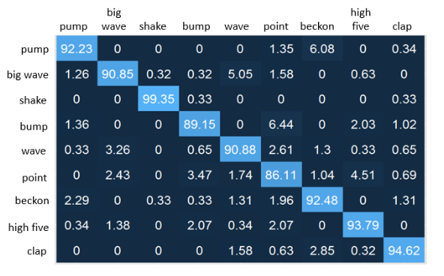

Figure 1: Confusion Matrix – Classified Gestures V Identified Gestures [1]

Stay connected
Stay Connected will have the implementation of the social gesture recognition algorithm, it requires a Bluetooth pairing with an Android phone and a smart band. In this case for testing we used a Microsoft Band 2 and a Samsung Galaxy 7.

Once the band and phone are paired the user is free to either sign up as a new user, or login with an existing account. This is a good addition because separate accounts assure privacy and the that ability to save personal content.

The user then can edit their account profile. For instance, they can edit their username, bio, and profile picture. Most importantly they can edit their list of hobbies; this ensures that when the user is challenged daily that each challenge is unique enough to make sure that the user meets someone new out of their normal friend circle.

The main profile screen for Stay Connected displays the users name, location, bio, hobbies and badges awarded. Their daily challenged is also displayed to encourage and remind the user of their prospective goal for the day. Below the daily challenge is the recent activity of the user; this is only within a days’ time, that way the user has an easy way to access and ensure they are being socially active during the given day.

The most effective button on the main profile screen is the button that shows the activity history of the user. This is the activity and badges and awarded from the time the user created their account. Furthermore, the user has the option to add notes to any activity or badged awarded. This way the user can take note of how they felt during a particular time when the activity took place. Overall this aspect is helpful for a user if they need to share their activity with a specialist such as a psychologist or even a family member.

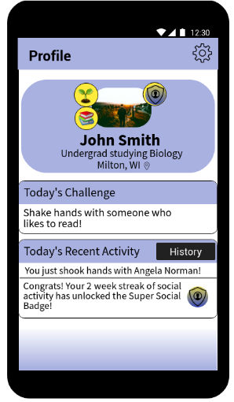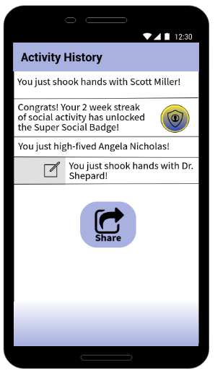
Wireframe 1 & 2: Profile Home Screen and Activity History

A goal for this app is to essentially provide the ability to encourage users to socialize with individuals different or outside of their comfort zone.

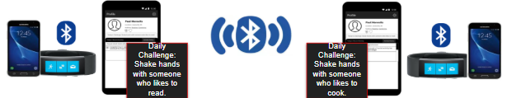
Figure 2: Diagram of Stay Connected

An additional goal is to detect if the user either is friends with someone they connect with or if they connect with a stranger. This is important because friends and strangers hold different levels of significance for one who is socially isolated.

Related work
Prior work related to the motivation of Stay Connected includes Cenceme and EmotionSense. Both developments are important to note because of their advancement of sensor detections in real-time. Cenceme reports social interactions like having a conversation, while EmotionSense detects the interaction of individuals and reports the emotion during the conversation.

Acknowledgment

I would like to thank Dr. Jamie Payton Associate Professor and Chair of the Department of Computer & Information Sciences at Temple University. I also thank Zaire Ali, PhD student for mentoring me throughout the REU program. Both Dr. Payton and Mr. Ali were very informative and helpful throughout my research experience. Lastly, I would like to thank the National Science Foundation for providing the funds for the REU program at Temple University; this program taught me skills I will use in the future.

References
[1] Knighten, Jonathan, Stephen McMillan, Tori Chambers, and Jamie Payton. "Recognizing social gestures with a wrist-worn smartband." In Pervasive Computing and Communication Workshops (PerCom Workshops), 2015 IEEE International Conference on, pp. 544-549. IEEE, 2015.
[2] Oscar D. Lara and Miquel A. Labrador. “Survey on Human Activity Recognition using Wearable Sensors” IEEE COMMUNICATIONS SURVEYS & TUTORIALS, VOL. 15, NO. 3, THIRD QUARTER 2013
[3] K. K. Rachuri, M. Musolesi, C. Mascolo, P. J. Rentfrow, C. Longworth, and A. Aucinas, “Emotionsense: A mobile phones based adaptive platform for experimental social psychology research,” in Proceedings of the 12th ACM International Conference on Ubiquitous Computing,ser. UbiComp, 2010, pp. 281–290.
[4] J. S. House, K. R. Landis, D. Umberson et al., “Social relationships and health,” Science, vol. 241, no. 4865, pp. 540–545, 1988.
[5] Payton, Jamie. “Recognizing Social Gestures with a Wrist Worn Smartband” Percom. PowerPoint

